**Day 3 – E-Mail Service**

1. Research the following internet protocols related to e-mail services.
   1. SMTP Protocol
      1. SMTP is a push protocol and is used to send the mail whereas POP (post office protocol) or IMAP (internet message access protocol) are used to retrieve those mails at the receiver's side. SMTP Fundamentals. SMTP is an application layer protocol.
   2. POP3 Protocol
      1. Post Office Protocol version 3 (POP3) is a standard mail protocol used to receive emails from a remote server to a local email client. POP3 allows you to download email messages on your local computer and read them even when you are offline.
   3. IMAP Protocol
      1. In computing, the Internet Message Access Protocol (IMAP) is an Internet standard protocol used by email clients to retrieve email messages from a mail server over a TCP/IP connection. IMAP is defined by RFC 3501
   4. Web Mail
      1. An email system in which a user can access their emails via a browser on any computer or device that is connected to the Internet.
2. Use the following resource as a starting point:  
   <https://askleo.com/what_is_pop_or_pop3_or_a_pop_account_and_what_about_smtp/>
3. Complete the following Venn Diagram to summarize your research.

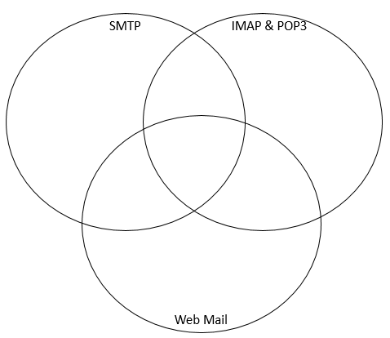

* POP3: Message access agent
* Between receiver and receivers mail
* Used to retrieve and organize mail from mailbox present on receiver’s mail server
* IMAP can’t send emails, but they can be used for receiving them.
* SMTP: Message transfer Agent
* Between senders and sender’s mail server, also sender and receivers mail server.
* Used to send mail from sender’s computer to receiver’s mail server

[Grab your reader’s attention with a great quote from the document or use this space to emphasize a key point. To place this text box anywhere on the page, just drag it.]

* All of these protocols deal with email.
* Also all of these protocols interact with each other.

* Uses http for sending/retrieving emails
* Operated from a website
* Can access email as long as you have internet access.
* Usually free email accounts that are operated from a website